TIGERS

By Jakob Messick



**What tigers look like**

Tigers are big and strong animals. Some tigers are orange and white with black stripes. Others are all white with black stripes.

Tigers are usually 2.6 to 3.6 ft tall.

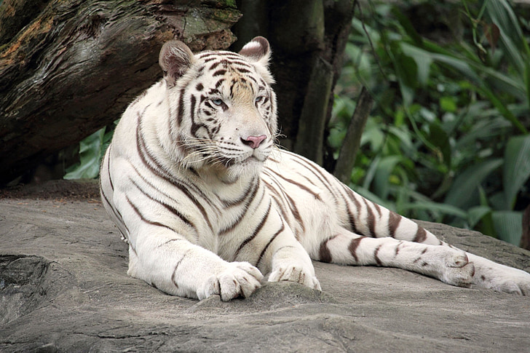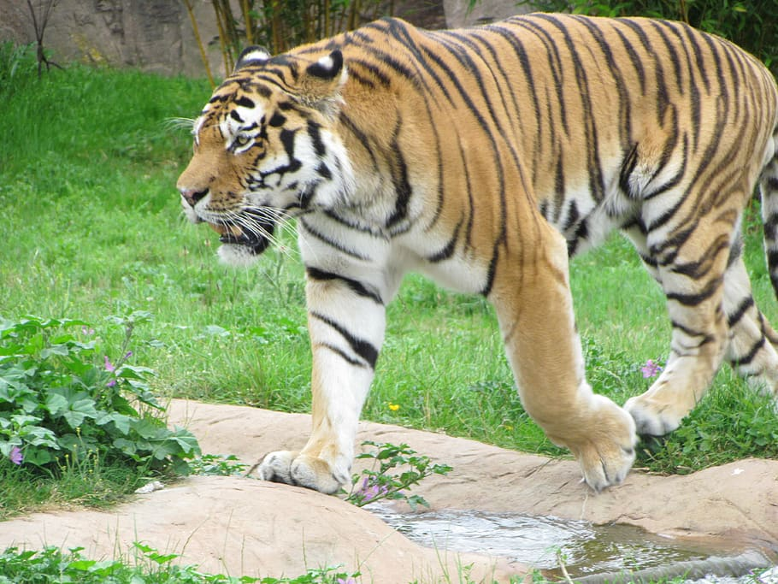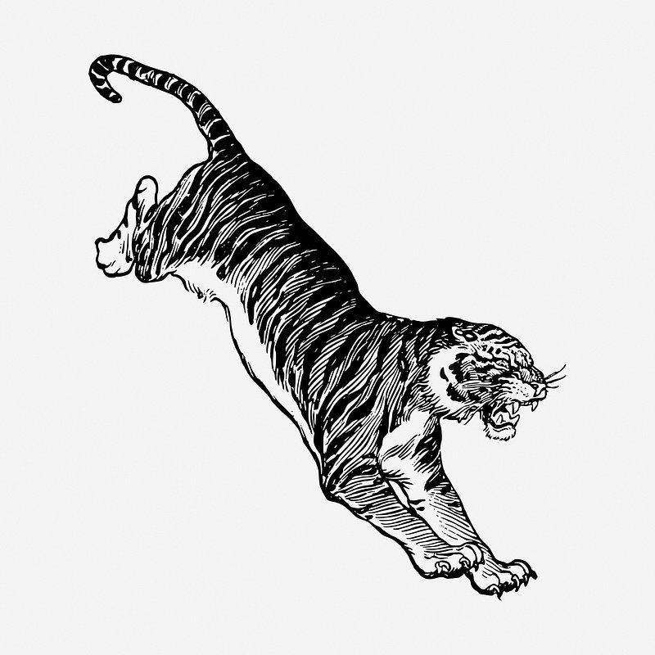

**What tigers eat**

Tigers eat wild boars, fish, birds, rodents, amphibians, reptiles, and even insects.Their teeth are super strong. It wouldn't take long to eat any of those creatures.

**Where tigers live**

Tigers are found in many places like the evergreen forest, mangrove swamps, and grasslands.

**Cubs**

Tigers typically give birth to between two and four cubs. Sadly half of the cubs only survive for 2 years. Tiger cubs are born blind. Cubs weigh 1.7 to 3.5 lb at birth.

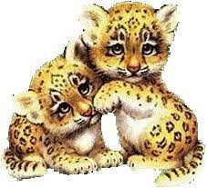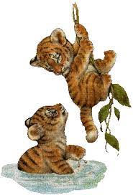

**What tigers do for fun**

Tigers like to swim and play in the water for hours. They sleep and rest for the day and at night they come out to feast on food.

**Interesting Tiger Facts**

* Tigers love to swim and play in the water.
* Tigers live for about 25 years.
* India has the largest number of wild tigers.
* Tigers have poor eyesight.
* Tigers have soft toe pads to help them sneak around at night.
* Tigers can jump 32 feet at a time!
* Tigers eat almost 60 lb of food every day!
* Male tigers can weigh up to 680 pounds!
* Tigers bite down with a force of a thousand pounds!
* Tiger teeth are 4 inches long and very sharp.
* Tigers can run as fast as a car on a highway!
* Tigers’ tails are 3 ft long.
* Every tiger has a different stripe pattern!
* Tigers can jump 18 to 20 ft long!
* Tigers’ enemies are dhole, alligator, elephant, and bears.

**In conclusion**

Tigers are big and super strong animals. Tigers are super cool animals!